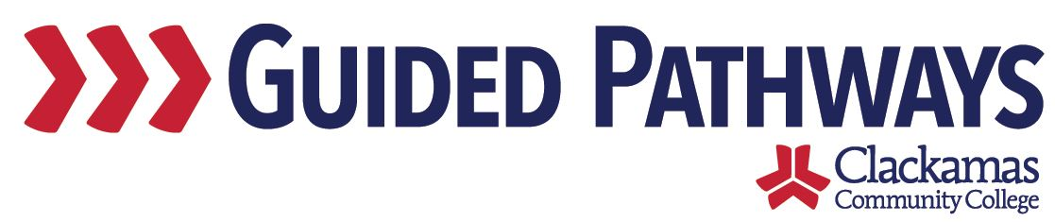
Guided Pathways Leadership Taskforce
Meeting Notes
January 4, 2021, 2:00–3:30 p.m. (Zoom)

- Welcome
- We’ll be discussing professional development at the February meeting

- Educational Focus Areas
- Lauren and Stephen joined the meeting to discuss how
- Lauren shared a report – Momentum Metrics
  - Trying for a while now to get a good solid report that could be useful to multiple groups
  - Has a lot of filters that are useful
- Stephen said that they are also building some infrastructure around student programs and EFA – he discussed the warehouse being utilized
- IR wants to be on the same page when building these things
- Trying to build in something where we can determine what that program would be if we don’t know their primary – get to one program per student
- Form being sent out periodically to find out their primary program – continuing and returning students

- Share videos from Guided Pathways Institute
- https://mediaspace.illinois.edu/media/t/1_mkt6n54r
- https://www.youtube.com/watch?v=u3aCKTfei_4&feature=youtu.be
- Breakout room discussion:
  - How do these videos connect to our work in Guided Pathways?
  - How can we work to cultivate equity?
  - What are we already doing?
  - What do we want to keep in mind as we proceed with our work?

- FYE Exemption Transfer Credit Cut-Off
- Lupe and Tara discussed cut-off for FYE exemption
- Original intent was to begin the FYE requirement for fall 2021, bumping up to fall 2022
- Not every student needs to take FYE – one of the exceptions that we’re struggling with are transfer students – how many credits they should have completed and what kind of timeframe
- 30 credit or 45 credit threshold? – or somewhere in between
- Credits transferred from a college, not ACC or dual-enrollment
- Discussion around the criteria for exception
- Just because a student has the number of credits may not mean they should receive the exception
- Want to make a system that catches the exceptions automatically rather than do it student-by-student to make it not labor-intensive
- 30 credits with a “PASS-like experience”
- Tara and Lupe will work on the exemption process further, based on 30 credits

- Updates from GP workgroups
- Workgroup leads shared brief updates on their work

- Review commitments and next steps
- Commitments and next steps were reviewed

